TOPIC : Healthcare Data Exploration

NAME : Harsh Kumar Mishra

UNIV. ROLL NO. : 202401100300114

BRANCH : CSE-AI

SECTION : B

SUBJECT : INTRODUCTION TO AI

SUBJECT CODE : AI101B

**Introduction**

In the modern healthcare industry, data analysis plays a crucial role in monitoring patients' health and identifying potential risks. This project focuses on analyzing healthcare data, including attributes such as Patient ID, Age, Blood Pressure, Sugar Level, and Weight. The goal is to compute basic statistics, identify patients at risk based on abnormal readings, and visualize the data for better insights. This report outlines the methodology used, provides the full Python code, and includes screenshots of the output.

**Methodology**

1. **Data Loading:** A dataset containing 20 sample patients was loaded using the Pandas library. The dataset was extracted from a CSV file and structured into a DataFrame.
2. **Statistical Analysis:** The describe() function was used to compute summary statistics, including mean, standard deviation, minimum, and maximum values for each attribute.
3. **Risk Identification:** Patients with blood pressure exceeding 140 or sugar levels above 180 were flagged as high-risk individuals.
4. **Data Visualization:** Two histograms were plotted using Matplotlib to represent the distributions of blood pressure and sugar levels across the sample population.

**Code Typed**

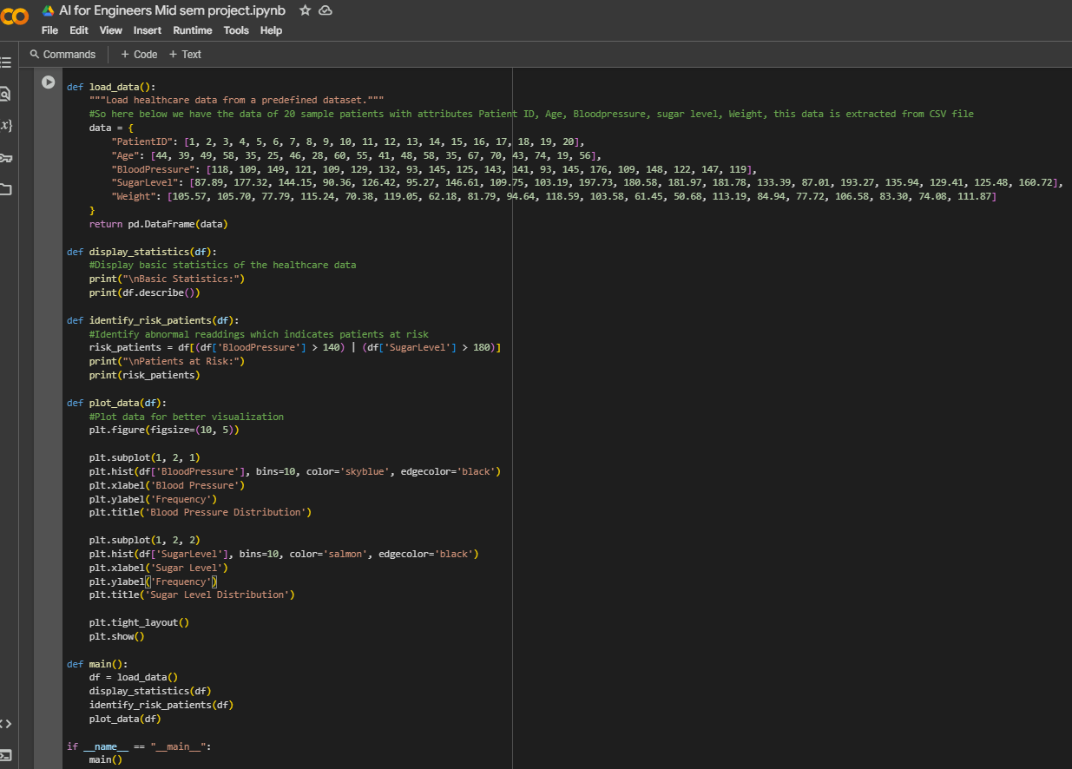

**Screenshots Output**

1. **Basic Statistics Output:**

1. **Patients at Risk Output:**

**3. Blood Pressure and Sugar Level Distribution:**

